Stochastic Project 2

**Group 16**

(bgl375, jt39634, mnk393, st32566)

February 26, 2018

Reading the data using the R file given:

data = read.csv("N100StkPrices.csv", header=TRUE)  
  
# cleaning up data  
data = na.omit(data)  
ticker = data$TICKER  
  
# spun off MDLZ  
delete = seq(1, dim(data)[1])[ticker == "MDLZ"]  
data = data[-delete, ]  
  
date = apply(as.matrix(data$date), MARGIN=1, FUN="toString")  
date = as.Date(date, "%Y%m%d")  
ticker = data$TICKER  
price = data$PRC  
shares = data$SHROUT  
  
# Accounting for changes in ticker names  
# KFT changed to KRFT in Oct 2012.  
ticker[ticker == "KFT"] = "KRFT"  
  
# SXCI changed to CTRX in Jul 2012.  
ticker[ticker == "SXCI"] = "CTRX"  
  
# HANS changed to MNST in Jan 2012.  
ticker[ticker == "HANS"] = "MNST"  
  
# convert prices to a matrix, arranged by rows of dates and columns of tickers  
unique_dates = sort(unique((date)))  
unique_tickers = sort(unique(ticker))  
  
priceMat = matrix(NA, length(unique_dates), length(unique_tickers))  
sharesMat = matrix(0, length(unique_dates), length(unique_tickers))  
  
for (i in 1:length(unique_tickers)) { # loop to create price and shares matrices  
 tic = unique_tickers[i]  
 idx = is.element(unique_dates, date[ticker==tic])  
   
 priceMat[idx, i] = price[ticker==tic]  
 sharesMat[idx, i] = shares[ticker==tic]  
}  
  
rownames(priceMat) = as.character(unique_dates)  
rownames(sharesMat) = as.character(unique_dates)  
  
rm(list = c("data", "delete", "i", "idx", "price", "shares", "tic", "ticker", "date"))  
  
# Read Monthly Data -------------------------------------------------------  
  
# read in the data  
mdata = read.csv("N100Monthly.csv", header = TRUE, stringsAsFactors = FALSE)  
  
# clean up data  
mdate = apply(as.matrix(mdata$date), MARGIN = 1, FUN = "toString")  
mdate = as.Date(mdate, "%Y%m%d")  
mticker = mdata$TICKER  
mprice = mdata$PRC  
mshares = mdata$SHROUT  
mticker[mticker == "FOXA"] = "NWSA"  
  
  
unique_mdates = sort(unique((mdate)))  
unique_mtickers = sort(unique(mticker))  
  
idx = is.element(unique_mtickers, unique_tickers)  
  
# if (!all(idx)) {  
# print("Warning: Some tickers seem to be missing")  
# }  
monthlyPriceMat = matrix(NA, length(unique_mdates), length(unique_tickers))  
for (i in 1:length(unique_tickers)) {  
 tic = unique_tickers[i]  
 idx = is.element(unique_mdates, mdate[mticker == tic])  
 monthlyPriceMat[idx, i] = mprice[mticker == tic]  
}  
  
rm("mdata", "i", "idx", "mprice", "mshares", "mticker", "tic", "mdate")

# Question 1

#Creating a return matrix to get returns of stocks using stock prices  
n = ncol(priceMat)  
d = nrow(priceMat)  
returnMat = matrix(NA, d, n) #d-1 by n matrix for daily returns  
rownames(returnMat) = unique_dates  
colnames(returnMat) = unique_tickers  
  
for (i in 1:n){  
 returnMat[2:d,i] = (priceMat[2:d,i] - priceMat[1:d-1,i])/priceMat[1:d-1,i]  
}

# Question 2

Here we have used the "Use" function in Cor to handle the NAs

corrMatrix = cor(returnMat, use="pairwise.complete.obs") #Calculate correlation matrix

# Question 3

Constraint 1 gives us 1 row, constraint 2 gives us n rows and constraint 3 gives us (n^2) rows. So we have matrix A initialized with 0s for (n^2 +n +1) rows and (n^2 +n) columns representing (n^2) x's and (n) y's.We have foudn the weights, normalized them and used them in the next question to solve for the portfolio shares.

library(lpSolve)  
constructFund <- function(rho, q, priceMat, sharesMat, unique_tickers, unique_dates){  
 n = length(unique_tickers)  
 d = length(unique_dates)  
   
 #Formulating the A, b, c of the integer program to be solved  
 c = c(as.vector(rho),rep(0,n))  
 A = matrix(0, n^2+n+1, n^2+n)  
 A[1,(n^2+1):(n^2+n)] = rep(1,n)  
 for (i in 1:n){  
 A[(i+1), (n*(i-1)+1):(n*i)] = rep(1,n)  
 }  
 A[(n+2):(n^2+n+1), 1:n^2] = diag(1,n^2)  
 A[(n+2):(n^2+n+1), (n^2+1):(n^2+n)] = matrix(rep(diag(-1,n),n), nrow=n^2, byrow=T)  
 b = c(q, rep(1,n), rep(0,n^2))  
 dir = c(rep('=',(n+1)),rep('<=',n^2))  
 s <- lp('max', c, A, dir, b, all.bin=TRUE)  
   
 share_last = sharesMat[d,]  
 price_last = priceMat[d,]  
 market_cap = share_last*price_last  
   
 similar = matrix(0,n,n)  
 for (i in 1:n){  
 similar[i,] = market_cap[i]*s$solution[(n*(i-1)+1):(n*i)]  
 }  
 weights = colSums(similar)  
 weights_adj = weights/sum(weights)  
 return(weights_adj)  
}

# Question 4

Here we have used the weights to choose what goes into our portfolio. We calculated both values and returns for NASDAQ as well as our own portfolio for comparison. The comparison plot has been plotted too.

library(ggplot2)  
q = 25  
investment = 1000000   
weights = constructFund(corrMatrix,q,priceMat, sharesMat, unique_tickers, unique_dates)  
weights_dollar = weights*investment  
  
portfolioShare = weights_dollar/priceMat[d,]  
nasdaqShares = investment/2660.93  
  
#multiply the number of shares with prices of each month  
nasdaqValues = nasdaqShares*c(2731.53, 2738.58, 2818.69, 2887.44, 2981.76, 2909.60, 3090.19, 3073.81, 3218.20, 3377.73, 3487.82, 3592)  
#portfolioValues = colSums(apply(monthlyPriceMat, 1, function(x) x*portfolioShare))  
  
portfolioValues = c(rep(0,12))  
  
for(i in 1:12){  
value_ij = 0  
 for(j in 1:100){  
 value_ij = value_ij + monthlyPriceMat[i,j]*portfolioShare[j]  
 }  
 portfolioValues[i] = value_ij  
 }  
  
#Calculating returns for NASDAQ and our portfolio  
nasdaqReturns = (nasdaqValues - investment)/investment  
portfolioReturns = (portfolioValues - investment)/investment  
  
Comparison = data.frame(c(1:12), nasdaqReturns, portfolioReturns)  
colnames(Comparison) = c('MONTH', 'NASDAQ', 'PORTFOLIO')  
View(Comparison)

plot(Comparison$MONTH, Comparison$PORTFOLIO, col = 'red', type = 'b',   
 xlab = 'month', ylab = 'return', xlim = c(0,12), ylim = c(0, 0.4))  
lines(Comparison$MONTH, Comparison$NASDAQ, col = 'blue', type = 'b', lty=2)  
legend("topleft",legend = c('Portfolio','NASDAQ'), col = c('red','blue'), lty = 1:2, cex = 0.8)

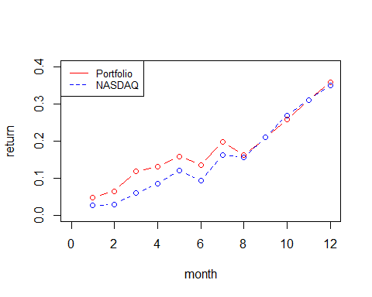

From October onwards, both NASDAQ and our portfolio show negligible differences. Before October, Portfolio returns are higher than the NASDAQ values.

# Question 5

We use correlation matrix of market cap as the similarity measure here. We now have a new portfolio to compare with NASDAQ. The similarity matrix has also been defined below.

similarityMat <- function(priceMat, sharesMat, unique_tickers,unique_dates){  
 market_cap = priceMat*sharesMat  
 corrMatrix = cor(market_cap, use = "pairwise.complete.obs")  
 return(corrMatrix)  
}  
rho = similarityMat(priceMat,sharesMat,unique_tickers, unique_dates)  
  
weights2 = constructFund(rho,q,priceMat, sharesMat, unique_tickers, unique_dates)  
weights_dollar2 = weights2*investment  
portfolioShare2 = weights_dollar2/priceMat[d,]  
#portfolioValues2 = colSums(apply(monthlyPriceMat, 1, function(x) x*portfolioShare2))  
portfolioValues2 = c(rep(0,12))  
  
for(i in 1:12){  
value_ij = 0  
 for(j in 1:100){  
 value_ij = value_ij + monthlyPriceMat[i,j]*portfolioShare2[j]  
 }  
 portfolioValues2[i] = value_ij  
}  
  
portfolioReturns2 = (portfolioValues2 - investment)/investment  
Comparison$PORTFOLIO2 = portfolioReturns2  
View(Comparison)

plot(Comparison$MONTH, Comparison$PORTFOLIO, col = 'red', type = 'b',   
 xlab = 'month', ylab = 'return', xlim = c(0,12), ylim = c(0, 0.4))  
lines(Comparison$MONTH, Comparison$PORTFOLIO2, col = 'dark green', type = 'b', lty=3)  
lines(Comparison$MONTH, Comparison$NASDAQ, col = 'blue', type = 'b', lty=2)  
  
legend("topleft",legend = c('Portfolio','Portfolio2','NASDAQ'), col = c('red','dark green','blue'), lty = c(1,3,2), cex = 0.7)

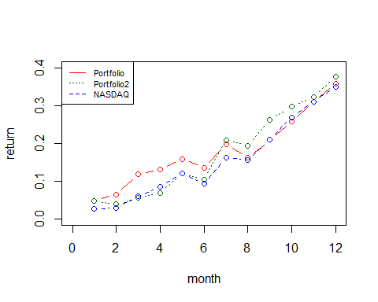

We see that the new portfolio performs better than the old after 7th month (July). However, both these portfolios track the NASDAQ quite closely.